SOA EXPERIMENT – 5

Securing APIs with CORS

STEP1 – OPEN spring tool suite
File → New → Spring Starter Project

Name : cors-demo
Type : Maven
Packaging : Jar
Java : 17
Group : com.example
Artifact : cors-demo
Dependency : spring web

STEP2 – PROJECT STRUCTURE
cors-demo
│
├── src/main/java
│ └── com.example.demo
│ ├── SoaCorsDemoApplication.java
│ └── ProfileController.java
│
├── src/main/resources
│ └── application.properties
│
└── pom.xml
STEP3 – OPEN SoaDemoApplication.java
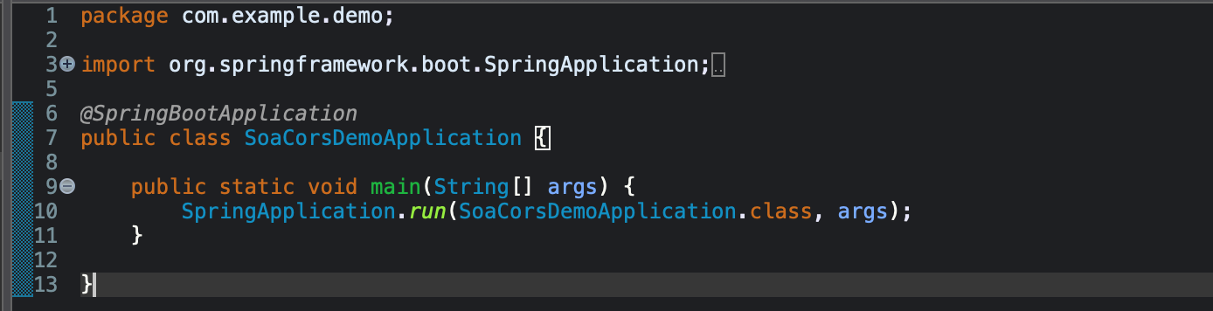

STEP4 – application.properties

STEP5 – OPEN com.example.demo
-> Create a new class called “ProfileController”
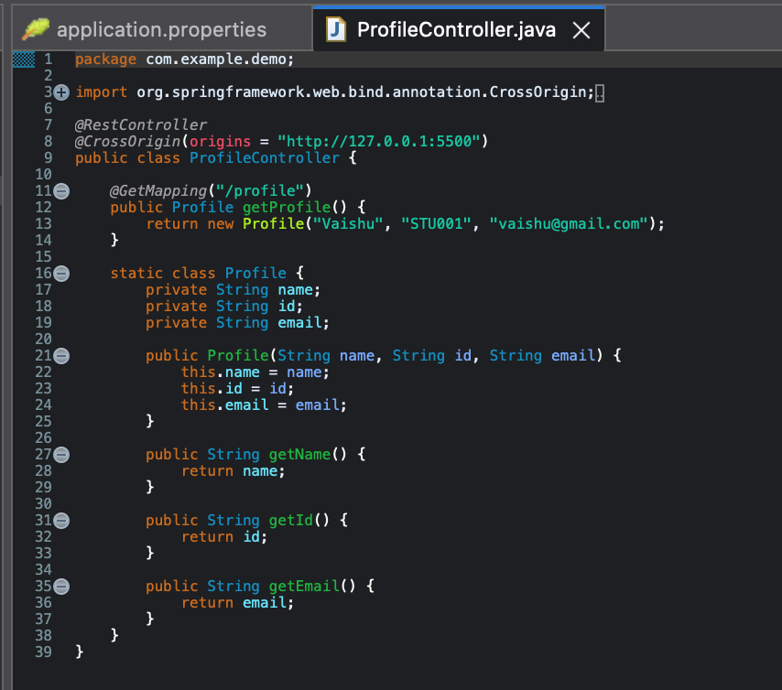
STEP6 – Run the backend
Right-click SoaCorsDemoApplication.java
→ Run As
→ Spring Boot App
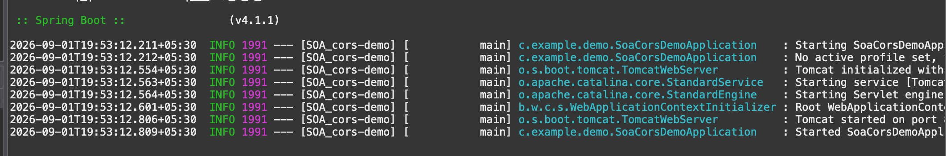

STEP7 – Test backend API
-> Open http://localhost:8082/profile
-> the API should return:-
{
"name": "Vaishu",
"id": "STU001",
"email": "vaishu@gmail.com"
}

STEP8 – Create Frontend
-> Open vs code and create a folder “cors-frontend”, in that create a file called “index.html”
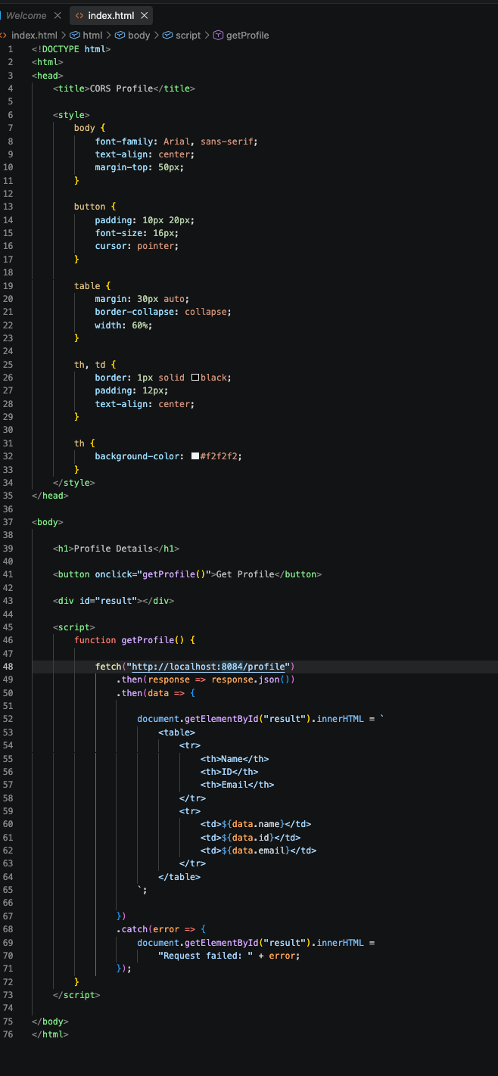
STEP9 – Run frontend
-> in vs code – “go live”
STEP10 – TEST CROS
-> OPEN http://127.0.0.1:5500/index.html
-> Click “get profile”
output :-
Name | ID | Email
Vaishu | STU001 | vaishu@gmail.com

